# CS 340 AAC README

## About the Project/Project Title

The project is for the Austin Animal Shelter and Grazioso Salvare.

## Motivation

This project is for the Austin Animal Shelter to CRUD ( create, read, update, and delete) their database. This software for is also for Grazioso Salvare, which is an innovative rescue-animal training company. The motivation behind this project is to increase and grow the company’s ability to find dogs that are available for adoption.

## Getting Started

To get started import the needed data into mongo. Then edit the python code for the user, password, and port number.

## Installation

Tools needed for the software is MongoDB, Python 3+/Jupyter, and PyMongo driver all being the latest version

You must import the data to the MongoDB then

## Usage

*Use this space to show useful examples of how your project works and how it can be used. Be sure to include examples of your code, tests, and screenshots.*

### Code Example

# Complete this create method to implement the C in CRUD.

def create(self, data):

if data is not None:

self.database.animals.insert_one(data) # data should be dictionary

return True

else:

raise Exception("Nothing to save, because data parameter is empty")

return False

# Create method to implement the R in CRUD.

def read(self, query):

if query is not None:

self.database.animals.find(query)

return True

else:

self.database.animals.find({})

return False

### Tests

The tests are for the read and create functions:

crud = AnimalShelter()

bird = {"animal_id":"A999901", "animal_type":"Parakeet", "breed":"Budgie", "color":"green"}

print(bird)

crud.create(bird)

crud.read(bird)

### Screenshots

*

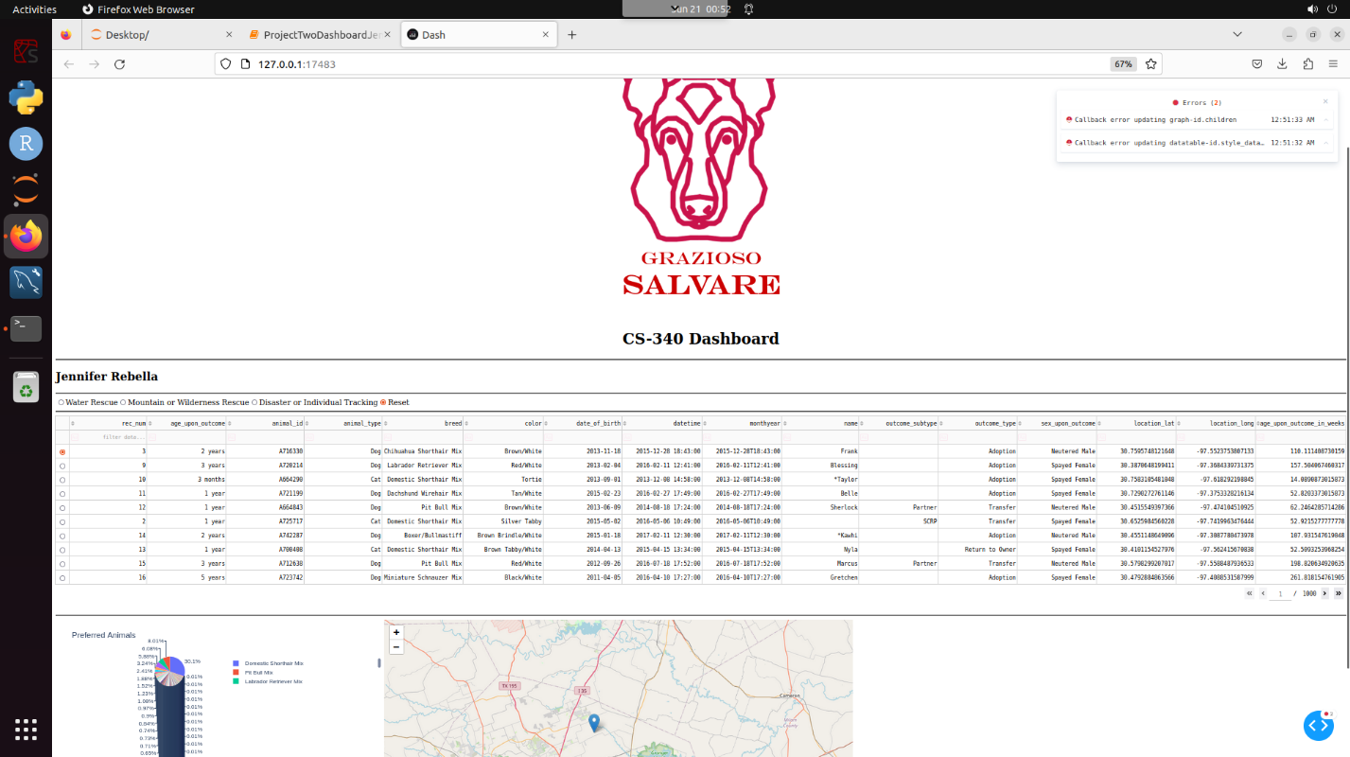

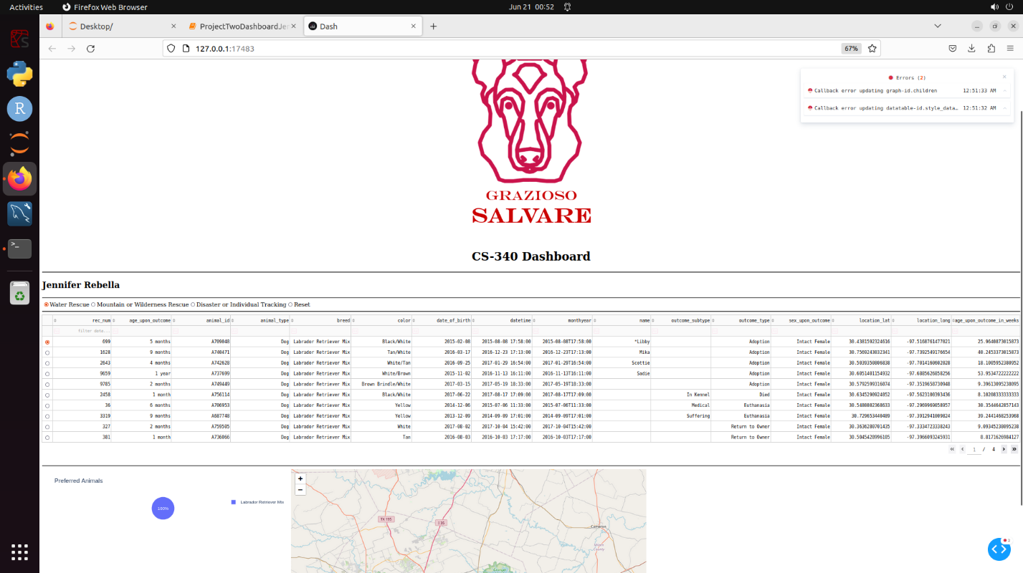

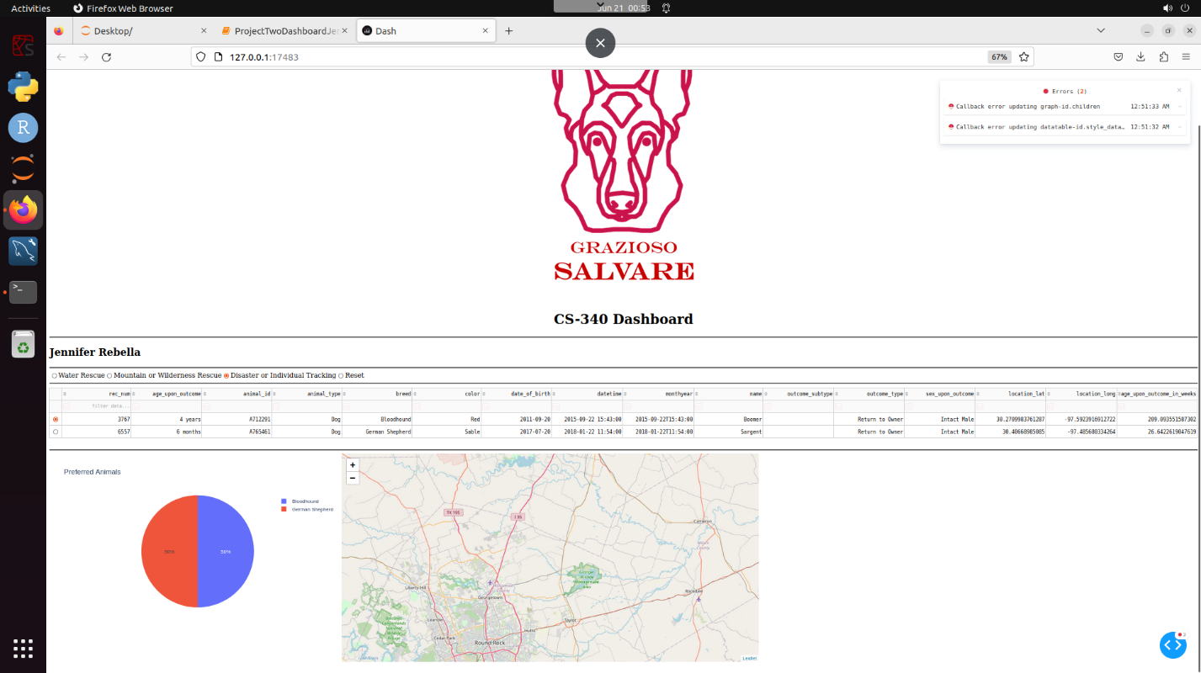

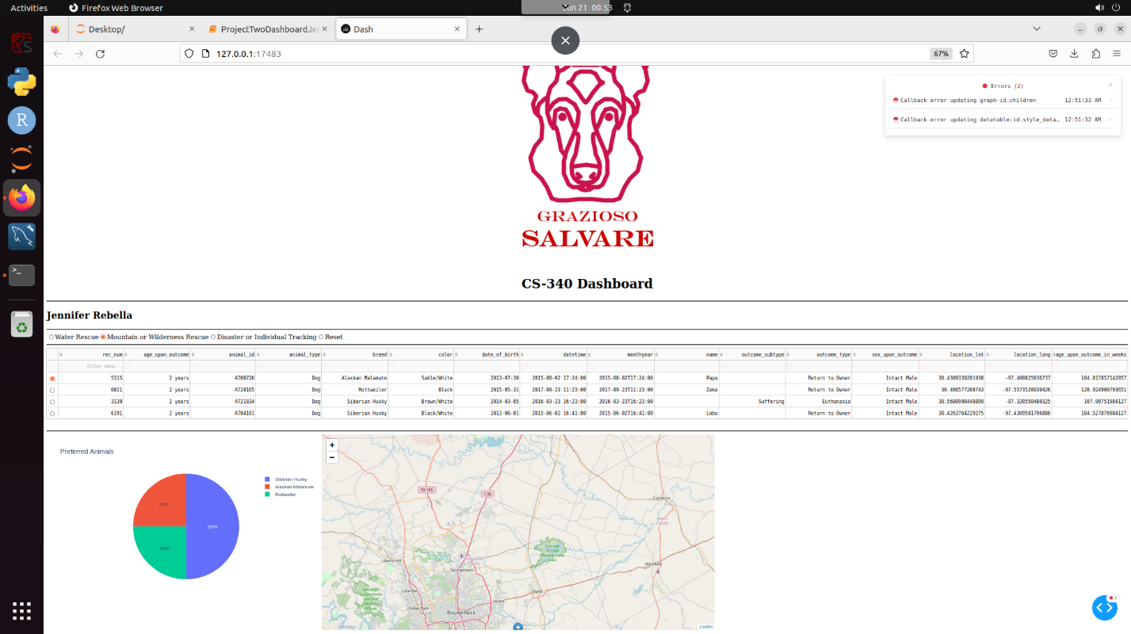

## Contact: Jennifer Rebella